Final review 1

# Author = 'Darren Isaacson'

# This program is designed add, multiply, check the smallest and largest number, and convert information into a table.

def main():

firstNum, secondNum, thirdNum = getInput()

firstNum, secondNum, thirdNum,add,multiply = calculateSum(firstNum,secondNum,thirdNum)

firstNum, secondNum, thirdNum, max = largeNum(firstNum,secondNum, thirdNum)

firstNum, secondNum, thirdNum, min = smallNum(firstNum, secondNum, thirdNum)

tableOutput(firstNum,secondNum,thirdNum,add,multiply,max,min)

def getInput():

value1 = int(input("Enter in your 1st value:"))

value2 = int(input(("Enter in your 2nd value:")))

value3 = int(input("Enter in your 3rd value:"))

return value1, value2, value3

def calculateSum(firstNum,secondNum,thirdNum):

add = firstNum + secondNum + thirdNum

multiply = firstNum * secondNum * thirdNum

return firstNum,secondNum,thirdNum,add,multiply

def largeNum(firstNum,secondNum, thirdNum):

if (firstNum < secondNum) and (firstNum < thirdNum):

max = firstNum

elif(secondNum < firstNum) and (secondNum < thirdNum):

max = secondNum

else:

max = thirdNum

return firstNum, secondNum, thirdNum, max

def smallNum(firstNum, secondNum, thirdNum):

if (firstNum > secondNum) and (firstNum > thirdNum):

min = firstNum

elif (secondNum > firstNum) and (secondNum > thirdNum):

min = secondNum

else:

min = thirdNum

return firstNum, secondNum, thirdNum, min

def tableOutput(firstNum,secondNum,thirdNum,add,multiply,max,min):

print("First\tSecond\tThird\tMax\t\tMin\t\tAdd\t\tMultiply")

print("%d\t\t%d\t\t%d\t\t%d\t\t%d\t\t%d\t\t%d\t\t" % (firstNum, secondNum, thirdNum, min, max, add, multiply))

main()

Output

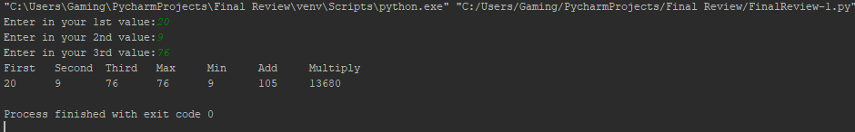

Final review 2

# Author = "Darren Isaacson"

# This program is designed to calculate the amount of alphabetical characters being used in a sentence.

import re

def main():

sentence = getInput()

regexConvert(sentence)

def getInput():

sentence = input("Enter in your sentence here:")

sentence = sentence.lower()

return sentence

def regexConvert(sentence):

alphabet = ["a","b","c","d","e","f","g","h","i","j","k","l","m","n","o","p","q","r","s","t","u","v","w","x","y","z"]

alphaCounter = [0,0,0,0,0,0,0,0,0,0,0,0,0,0,0,0,0,0,0,0,0,0,0,0,0,0]

for num in range(26):

for letter in (sentence): # Counts

if alphabet[num] == letter:

alphaCounter[num]+=1

print(alphabet)

print(alphaCounter)

main()

Output

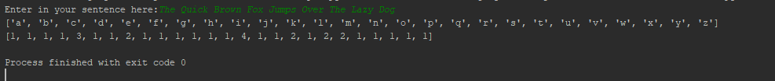

Final review 3

# Author = 'Darren Isaacson'

# This program is designed to create a csv file that

import csv, math

def main():

# list = getInput()

# csvConverter(list)

list = intConverter()

tableConverter(list)

def getInput():

dataList = []

while True:

numLine = []

value1 = int(input("Enter value #1:"))

numLine.append(value1)

value2 = int(input("Enter value #2:"))

numLine.append(value2)

value3 = int(input("Enter value #3:"))

numLine.append(value3)

value4 = int(input("Enter value #4:"))

numLine.append(value4)

value5 = int(input("Enter value #5:"))

numLine.append(value5)

# sum = value1+value2+value3+value4+value5

# numLine.append(sum)

dataList.append(numLine)

another = input("Would you like to enter another line of numbers? Press enter to enter another line. Otherwise enter any other key:")

if another == '':

print('--------------------------------------------------------------')

else:

break

return dataList

def csvConverter(list):

fileList = open('List.csv', 'w', newline='')

for row in range(len(list)):

fileWriter = csv.writer(fileList)

fileWriter.writerow(list[row])

fileList.close()

def intConverter():

motherList = []

fileList = open('List.csv')

filelistReader = csv.reader(fileList)

for row in filelistReader:

intList= []

totalsum = 0

for i in range(len(row)):

value = row[i]

intList.append(int(value))

totalsum += int(value)

intList.append(totalsum)

motherList.append(intList)

# totalsum = sum(intList)

# intList.append(totalsum)

# motherList.append(intList)

# print(intList)

return motherList

def tableConverter(motherlist):

title = ['First','Second','Third','Forth','Fifth','Sum']

print('{:<15} {:<15} {:<15} {:<15} {:<15} {:<15}'.format(*(title)))

for row in range(len(motherlist)):

print('{:<15} {:<15} {:<15} {:<15} {:<15} {:<15}'.format(*(motherlist[row])))

main()

Output

